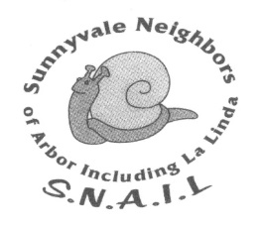
S.N.A.I.L. Neighborhood Association
Sunnyvale Neighbors of Arbor, Including LaLinda
PO Box 62072, Sunnyvale, CA 94088
http://www.snail.org/

Updated on: October 4, 2018
S.N.A.I.L. STANDING RULES
SNAIL Events
- SNAIL shall not loan out equipment for use to support an event that is not sponsored by SNAIL. (Passed 5/5/2016)

- SNAIL does not pay for alcohol. (Passed 9/8/2016)

- SNAIL Block Parties: (Passed 10/4/2018)
  - Reimbursement shall be up to $25 + $4 per resident, their children and guests who attend. Reimbursement cannot be higher than amount shown on receipts submitted with the reimbursement request.

SNAIL Monthly Newsletter
Priority for accepting and reviewing advertising: (Passed 1/4/2018)
- Ads will be accepted or renewed according to the priority stated below and based on available openings as determined by the newsletter editor:
- SNAIL residents with businesses.
- SNAIL businesses.
- Sunnyvale businesses.
- A copy of every SNAIL newsletter is available in the Newsletter Archive on the SNAIL website.

- Newsletter Advertisement Costs: (Passed 1/4/2018)
  - One month for $35.00
  - Six months for $200 ($33.33/mo.)
  - Twelve months for $390 ($32.50/mo.)

- Non-Profit or Fundraiser Articles: (Passed 1/4/2018)
- Articles must be for organizations or events in Sunnyvale, endorsed by the City of Sunnyvale, or
- Articles must be for organizations or events in Sunnyvale or neighboring cities submitted by SNAIL neighbors associated with those organizations or events.
- Articles will be published based on available space as determined by the newsletter editor.

